**Experiment 7:**

Create a Virtual Machine with 1 CPU, 2GB RAM and 15GB storage disk using a Type 2

Virtualization Software.

Step 1: Creating a New Virtual Machine.

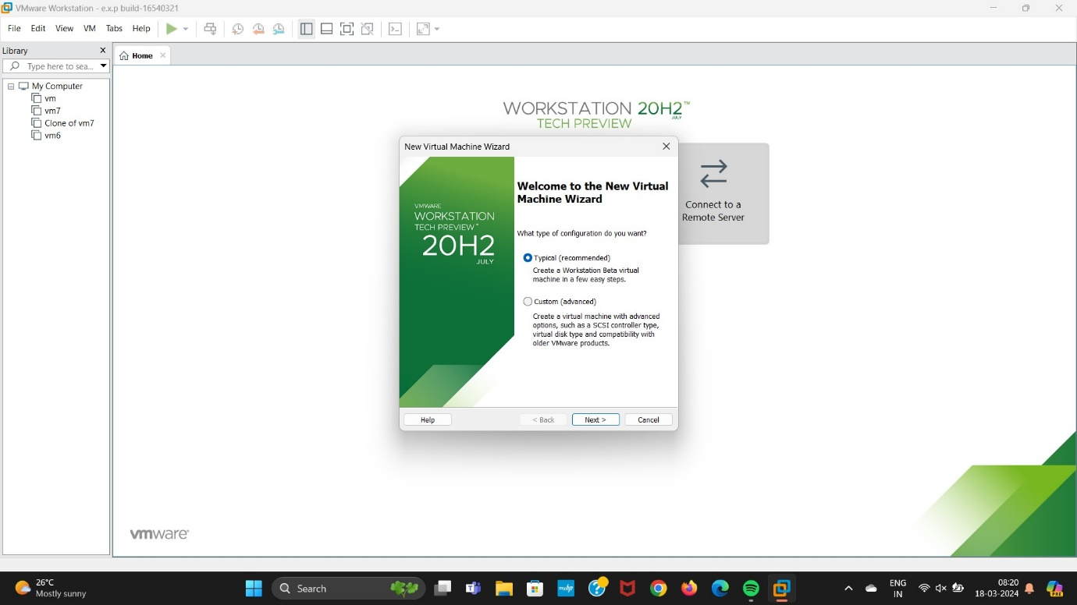

Step 2: Install Disk Image File.

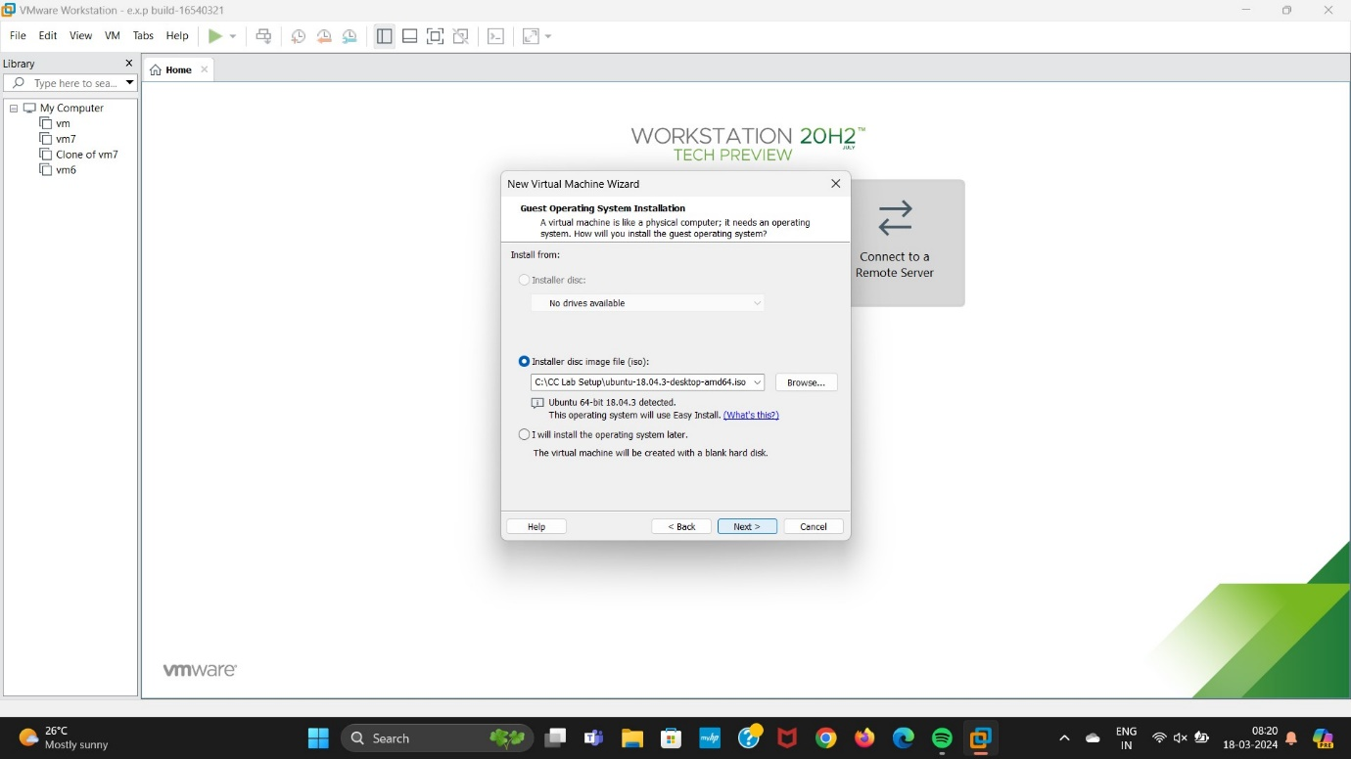

Step 3: Choosing any Operating System.

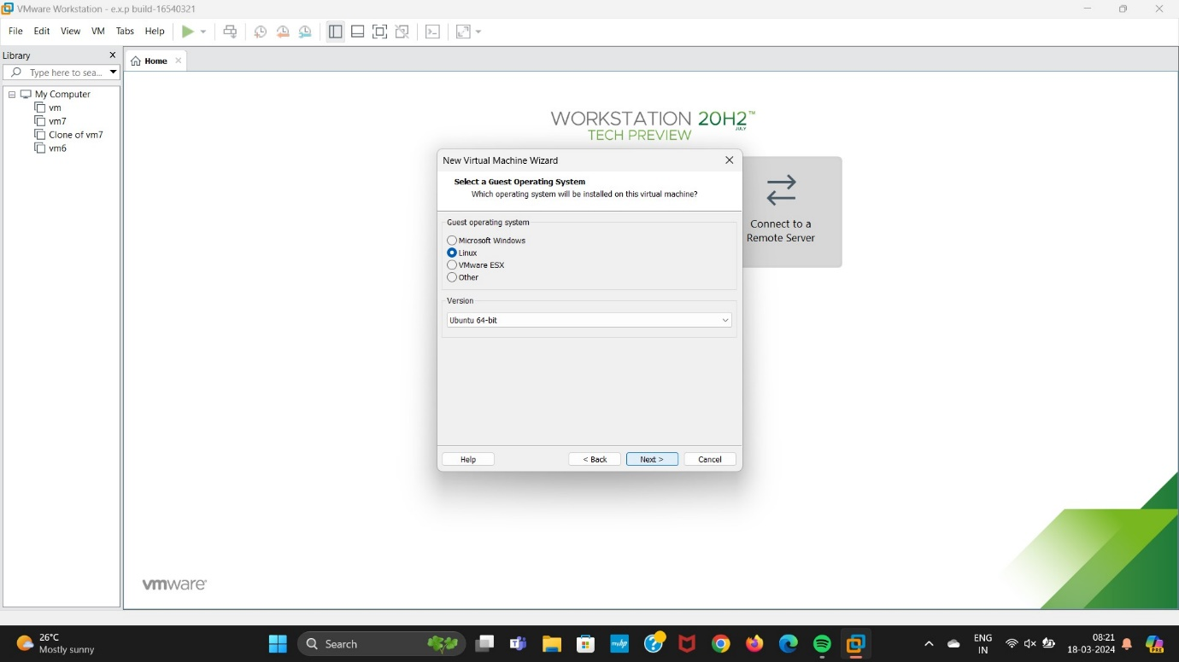

Step 4: Entering the Virtual Machine Name.

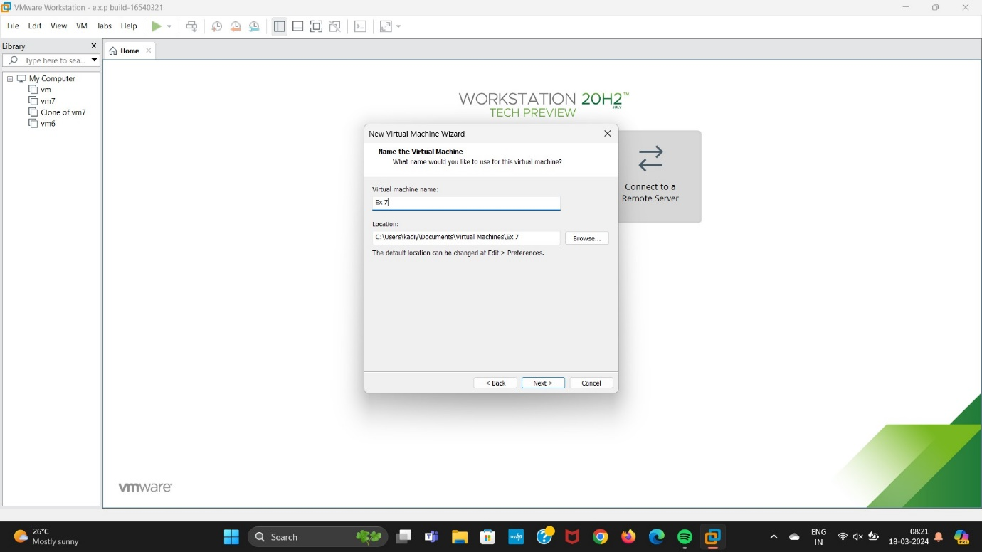

Step 5: Selecting the Maximum Disk storage.

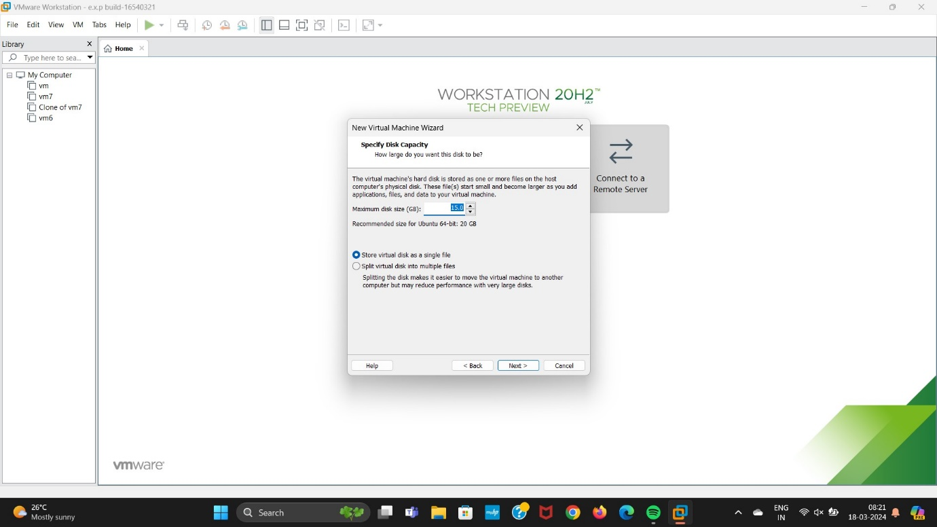

Step 6: Click on the Finish Button.

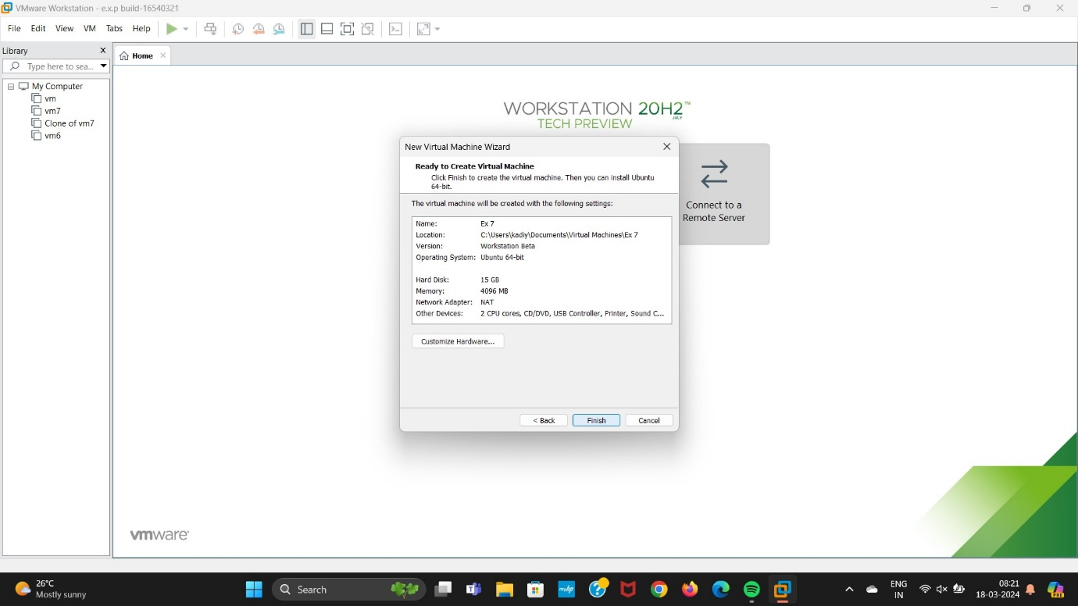

Step 7: Changing the Processor and Memory.

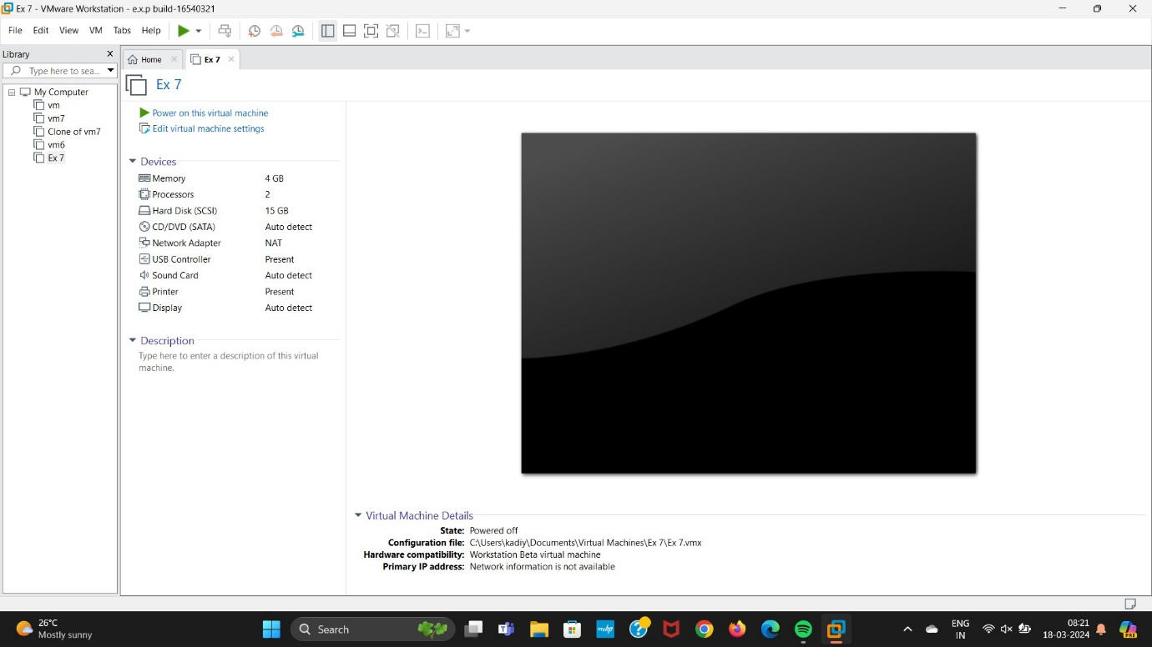

Step 8: Final Output.

